URL: http://www.surgcare.co.za/default.asp

We have provided an unbroken 24-hour service to our colleagues and patients ever since. We pride ourselves on our commitment to the highest of ethical surgical practice. We are able to provide a full range of surgical skills, endeavoring to improve past standards, blending senior experience and younger enthusiasm and ensuring that new skills are introduced to the group.

**Services:**

[Vascular Surgery](http://www.surgcare.co.za/A_ourservices.asp#Anchor-Arteria-1399)

[Venous Surgery](http://www.surgcare.co.za/A_ourservices.asp#Anchor-Venou-13213)

[Laparoscopic Surgery](http://www.surgcare.co.za/A_ourservices.asp#Anchor-Laparoscop-19025)

[Endoscopy](http://www.surgcare.co.za/A_ourservices.asp#Anchor-Endoscop-34972)

[Hepato-Biliary Surgery](http://www.surgcare.co.za/A_ourservices.asp#Anchor-Hepa-37612)

[Gastro-Intestinal Surgery](http://www.surgcare.co.za/A_ourservices.asp#Anchor-Upp-49639)

[Colo-rectal Surgery](http://www.surgcare.co.za/A_ourservices.asp#Anchor--Up-53067)

[Pancreatic Surgery](http://www.surgcare.co.za/A_ourservices.asp#Anchor-Hepa-37612)

[Breast Surgery](http://www.surgcare.co.za/A_ourservices.asp#Anchor-Brea-857)

[Diabetic Foot Clinic](http://www.surgcare.co.za/E_DiabeticFootclinic.asp)

[Head and Neck Surgery](http://www.surgcare.co.za/A_ourservices.asp#Anchor-28200)

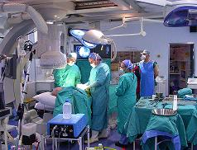 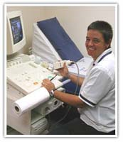 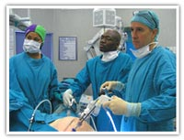 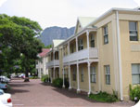

**Contact us**

Harfield House  
Kingsbury Hospital  
Wilderness Road  
Claremont  
Cape Town, South Africa

Tel +27 21 683-3893

Fax +27 21 683-1331